Human Actions Spec Sheet 10/19/13

**Purpose:** To outline the actions associated with CCC Human. Captain Copy Cat’s abilities as a human will serve as points of reference for the user to compare how a superpower improves Captain Copy Cat.

**Graphics Definitions:** This section will define general terms for graphics and UI. These terms will be used in tables containing specs for individual graphics.

**Stop/Wait Graphics (SWG):** These graphics will be used when waiting for the user to interact with the game or in specific cases (wait for instructions, fell down, etc).

**Action Graphics (AG):** These graphics will be objects that have a short, looping animation associated with them (running, jumping) that are called with a specific UI gesture.

**Transition Animations (TA):** If a transition animation is called (between superpowers, stand to crawl, etc), the right hand regions should stop listening for finger contact until the end of the transition animation. If at the end of the animation there is no finger, the “stop” or “waiting” graphic will be called.

**User Interface**: The screen will be split into regions 1-6, see Figure 1b:

**Region 1 (left hand region)**- To be controlled with the left thumb or finger. The region will listen for taps or swipes that will control specific actions and or call specific animations (jumping, crawling, transition animations, etc). The specific call action associated with each graphic can be found in Table 1.

**Region 3-6 (right hand regions):** These regions will be used to control the direction and speed of CCC by the right thumb or finger. If the user’s thumb is in region 3, CCC will move left fast. If their thumb is in region 4, CCC will move left slow. If their thumb is in region 5, CCC will move right slow. If their thumb is in region 6, CCC will move right fast. If they REMOVE their thumb, CCC will stop.

**Region 2:** This region is meant to provide a buffer between the left side and the right side of the screen. If their right finger crosses the line between 2 and 3 CCC will continue running left. In the event their right thumb crosses into region 1, ideally, the “stop” animation will be called. I’m not really sure the best way to use region 2 to prevent confusing right hand and left hand actions.

**Buttons:** The actions associated with the red “Main Menu” button in the bottom left corner and the purple and gray “Superpower Drawer” button in the top right should only be called when tapped. There may need to be boundaries around these buttons to separate the region they occupy from action regions 1-6.

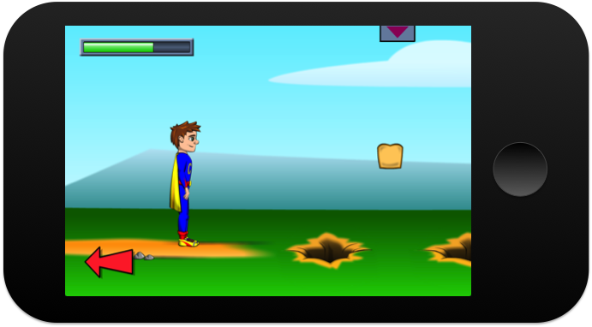 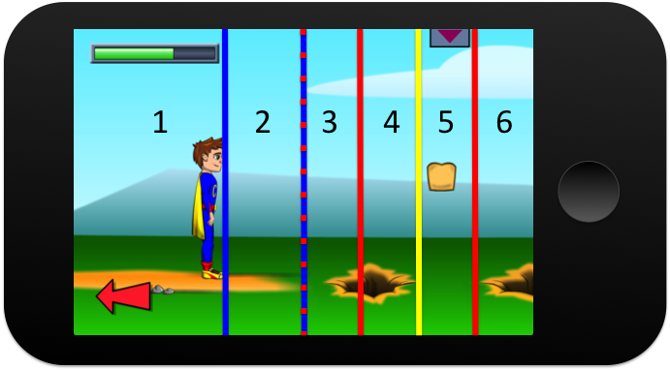

Figure 1a. A screen shot of CCC in a maze. The energy bar is in the upper left corner, the “Main Menu” button is the red arrow, the “Superpower Drawer” is the purple and grey tab in the upper left corner. Fig. 1b. The different UI regions. Region 1-action region, region 2-buffer, region 3-left fast, region 4-left slow, region 5-right slow, region 6-right fast.

**Table 1.** Specifications for all of the graphics/animations associated with CCC Human. Graphics dimensions are in the first column.

|  |  |  |  |  |  |
| --- | --- | --- | --- | --- | --- |
| **Action Name (Width x Height in pixels)** | **Pur­­pose** | **Boundary/Obstacle Interactions** | **Figure Kinetics** (Rates refer to speed at which the ground will move) | **User Interface (UI)** | Energy |
| Standing  (78.50 x 300 px) | SWG-Wait for the user to choose an action. | Gravity pulling CCC down to boundary line. | No movement, x or y. | The user is not interacting with the right-handed region. Also called if the character falls more than 800 px. | 0 |
| Walking  (131.5 x 300) | AG-Move in the direction the user wants to go. | Gravity pulling down to boundary line. Stop when hit a boundary line taller than 30 px in the positive y-direction (eg a wall). Continue moving if encounter a boundary line shorter than 30 px (eg a step). | Rate: **160 px/s**  Only control movement along x-axis, movement along y-axis dictated by boundary line. | Finger in regions 4 or 5, graphic will switch direction depending on region: 4-left, 5-right. | 0 |
| Running  (136.2 x 300) | AG-Move in the direction the user wants to go quickly. | Gravity pulling down to boundary line. Stop when hit a boundary line taller than 30 px in the positive y-direction (eg a wall). Continue moving if encounter a boundary line shorter than 30 px (eg a step). | Rate: **388 px/s**  Only control movement along x-axis, movement along y-axis dictated by boundary line. | Finger in regions 3 or 6, graphic will switch direction depending on region: 3-left, 6-right. | 0 |
| Leaping  (113.55 x 305.65) | AG-To jump over obstacles. | Gravity pulling down to boundary line. | Max Jumping height: **120 px**  Rate: same rate as either walking or running and is determined by the right hand region. | Tap in region 1. If there is no finger in the right hand region, CCC will jump straight up. If there is a finger in region 3-6, the rate will be the same as the walk or running rates. | 0 |
| Prepare to Crawl  (80.55 x 300) | TA-Transition from standing to crawling. | Gravity | Transition animations called to set CCC in a position to crawl. No change in position. | Swipe down in region 1. After this action actions associated with the right hand region will be: Wait to Crawl, Crawling, Stand up. | 0 |
| Wait to Crawl (244.45 x 151.6) | SWG-Waiting graphic before user “crawls”. | Gravity, can be under objects that are more than 5px over head. | No movement, x or y. | “Prepare to Crawl” has been called; there is no interaction in the right hand region. | 0 |
| Crawling (248.95 x 119.5) | AG-Move under obstacles. | Gravity, can move under objects that are 160 px apart. | Rate: **199 px/s**  Only control movement along x-axis, movement along y-axis dictated by boundary line. | Finger in region 5 or 6, crawl right. Finger in region 3 or 4, crawl left. Only one crawling speed. | 0 |
| Stand up  (244.45 x 151.6) | TA-Transition from crawling to standing. | Gravity; cannot call this action if a boundary line is within [5px:150px] of the top of CCC. | Transition animations called to set CCC in a standing position. No change in position. | Swipe up in region 1. Once transitional animation finish call “Standing”. After this action actions associated with the right hand region will be: Standing, Walking Running, Prepare to Crawl. | 0 |